Aşağıdaki örüntüleri tamamlayınız. Kare içine hangi varlık gelecekse resmin altındaki rakamı yazınız. Resimleri boyayınız.

[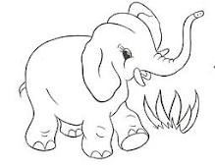](http://www.google.com.tr/imgres?imgurl=http://bp2.blogger.com/_eUk-4litSCk/R8rbFZhlyDI/AAAAAAAACAQ/v1gxJ0aCEgY/s400/deniz-yasemen.hayvanlar%2B(4).jpg&imgrefurl=http://www.frmartuklu.net/okul-oncesi-egitim/115122-sevimli-filler-boyama-sayfalari.html&usg=__HYxGWh--dlEQ2Ls6MZaEshHF6PA=&h=310&w=400&sz=24&hl=tr&start=146&zoom=1&tbnid=eg2iZ1hUUanQlM:&tbnh=117&tbnw=151&ei=vGQ4Tc2xK4P_4wbAmOXVCg&prev=/images%3Fq%3Dhayvan%2Bresmi%2Bboyama%26hl%3Dtr%26biw%3D1276%26bih%3D545%26gbv%3D2%26tbs%3Disch:1&itbs=1&iact=rc&dur=672&oei=ImE4TcnpHomo8QOC5cCrCA&esq=6&page=7&ndsp=22&ved=1t:429,r:11,s:146&tx=47&ty=70)[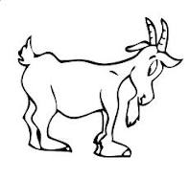](http://www.google.com.tr/imgres?imgurl=http://2.bp.blogspot.com/_QuIhYUot6Yo/TQ1fPNRVQTI/AAAAAAAACeA/Viy-nooEWs4/s640/Goat_Capra.gif&imgrefurl=http://cokzarifisler.blogspot.com/2010/12/cocuklar-icin-boyama-sayfalar.html&usg=__OufKEvAvVevMbYeajmQ3Z0kZYpQ=&h=546&w=577&sz=12&hl=tr&start=639&zoom=1&tbnid=fXDwiw7ukmQQcM:&tbnh=119&tbnw=126&ei=VGY4Tf_bE4ro4gbl6JGkCg&prev=/images%3Fq%3Dhayvan%2Bresmi%2Bboyama%26hl%3Dtr%26biw%3D1276%26bih%3D545%26gbv%3D2%26tbs%3Disch:1&itbs=1&iact=rc&dur=813&oei=W2U4TdKXFMeq8QP2lomwCA&esq=26&page=30&ndsp=23&ved=1t:429,r:12,s:639&tx=86&ty=71)[](http://www.google.com.tr/imgres?imgurl=http://bp2.blogger.com/_eUk-4litSCk/R8rbFZhlyDI/AAAAAAAACAQ/v1gxJ0aCEgY/s400/deniz-yasemen.hayvanlar%2B(4).jpg&imgrefurl=http://www.frmartuklu.net/okul-oncesi-egitim/115122-sevimli-filler-boyama-sayfalari.html&usg=__HYxGWh--dlEQ2Ls6MZaEshHF6PA=&h=310&w=400&sz=24&hl=tr&start=146&zoom=1&tbnid=eg2iZ1hUUanQlM:&tbnh=117&tbnw=151&ei=vGQ4Tc2xK4P_4wbAmOXVCg&prev=/images%3Fq%3Dhayvan%2Bresmi%2Bboyama%26hl%3Dtr%26biw%3D1276%26bih%3D545%26gbv%3D2%26tbs%3Disch:1&itbs=1&iact=rc&dur=672&oei=ImE4TcnpHomo8QOC5cCrCA&esq=6&page=7&ndsp=22&ved=1t:429,r:11,s:146&tx=47&ty=70)

[](http://www.google.com.tr/imgres?imgurl=http://2.bp.blogspot.com/_QuIhYUot6Yo/TQ1fPNRVQTI/AAAAAAAACeA/Viy-nooEWs4/s640/Goat_Capra.gif&imgrefurl=http://cokzarifisler.blogspot.com/2010/12/cocuklar-icin-boyama-sayfalar.html&usg=__OufKEvAvVevMbYeajmQ3Z0kZYpQ=&h=546&w=577&sz=12&hl=tr&start=639&zoom=1&tbnid=fXDwiw7ukmQQcM:&tbnh=119&tbnw=126&ei=VGY4Tf_bE4ro4gbl6JGkCg&prev=/images%3Fq%3Dhayvan%2Bresmi%2Bboyama%26hl%3Dtr%26biw%3D1276%26bih%3D545%26gbv%3D2%26tbs%3Disch:1&itbs=1&iact=rc&dur=813&oei=W2U4TdKXFMeq8QP2lomwCA&esq=26&page=30&ndsp=23&ved=1t:429,r:12,s:639&tx=86&ty=71)

1 2 1 2

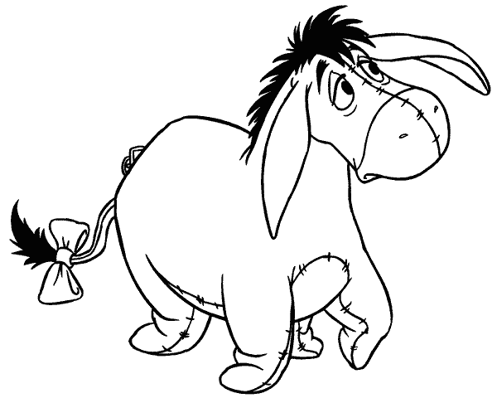



[](http://www.google.com.tr/imgres?imgurl=http://img03.blogcu.com/images/m/i/n/miniksirinlerim/chien2_1244585041.gif&imgrefurl=http://manzaram.blogcu.com/etiket/korkun%25C3%25A7%2520hayvan%2520resimleri&usg=__FM7XQUXdC_jtnpuIISxuTdN-_wk=&h=588&w=600&sz=46&hl=tr&start=146&zoom=1&tbnid=Qya-M3kSc5v2nM:&tbnh=122&tbnw=124&ei=8WQ4TczfMIiM4gaJ0KG5Cg&prev=/images%3Fq%3Dhayvan%2Bresmi%2Bboyama%26hl%3Dtr%26biw%3D1276%26bih%3D545%26gbv%3D2%26tbs%3Disch:1&itbs=1&iact=rc&dur=140&oei=ImE4TcnpHomo8QOC5cCrCA&esq=3&page=7&ndsp=22&ved=1t:429,r:6,s:146&tx=62&ty=84)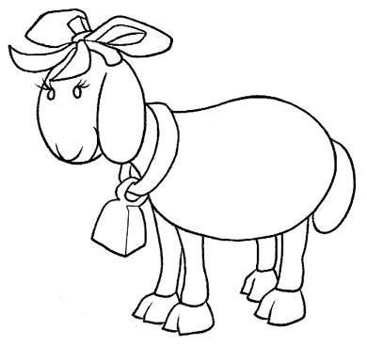[](http://www.google.com.tr/imgres?imgurl=http://img03.blogcu.com/images/m/i/n/miniksirinlerim/chien2_1244585041.gif&imgrefurl=http://manzaram.blogcu.com/etiket/korkun%25C3%25A7%2520hayvan%2520resimleri&usg=__FM7XQUXdC_jtnpuIISxuTdN-_wk=&h=588&w=600&sz=46&hl=tr&start=146&zoom=1&tbnid=Qya-M3kSc5v2nM:&tbnh=122&tbnw=124&ei=8WQ4TczfMIiM4gaJ0KG5Cg&prev=/images%3Fq%3Dhayvan%2Bresmi%2Bboyama%26hl%3Dtr%26biw%3D1276%26bih%3D545%26gbv%3D2%26tbs%3Disch:1&itbs=1&iact=rc&dur=140&oei=ImE4TcnpHomo8QOC5cCrCA&esq=3&page=7&ndsp=22&ved=1t:429,r:6,s:146&tx=62&ty=84)[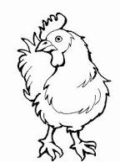](http://www.google.com.tr/imgres?imgurl=http://img88.imageshack.us/img88/3163/kopyas1horozqq8.gif&imgrefurl=http://www.frmartuklu.net/okul-oncesi-egitim/56810-ciftlik-hayvanlari-boyama-kitapcigi.html&usg=__aChywgKx8alJpk3o3aGPNaFBLxA=&h=1024&w=768&sz=14&hl=tr&start=25&zoom=1&tbnid=aQGewaNXP05q2M:&tbnh=121&tbnw=91&ei=X2E4TdjNKYq44gakhrjqCg&prev=/images%3Fq%3Dhayvan%2Bresmi%2Bboyama%26hl%3Dtr%26biw%3D1276%26bih%3D545%26gbv%3D2%26tbs%3Disch:1&itbs=1&iact=rc&dur=828&oei=ImE4TcnpHomo8QOC5cCrCA&esq=2&page=2&ndsp=24&ved=1t:429,r:14,s:25&tx=55&ty=53)[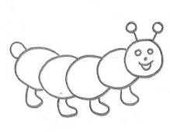](http://www.google.com.tr/imgres?imgurl=http://bp0.blogger.com/_eUk-4litSCk/R8raR5hlx-I/AAAAAAAAB_o/aU6laR1pTjI/s400/deniz-yasemen.hayvanlar%2B(9).jpg&imgrefurl=http://www.forumalev.net/okul-oncesi-egitim/387080-yuruyen-tirtil-boyama-sayfalari.html&usg=__HjXRVm47MtgnkPOzUD-xP_tvatc=&h=311&w=400&sz=18&hl=tr&start=364&zoom=1&tbnid=3qYX0K1SY7kGnM:&tbnh=112&tbnw=144&ei=6GU4TenaLJKq8AOo54mcCA&prev=/images%3Fq%3Dhayvan%2Bresmi%2Bboyama%26hl%3Dtr%26biw%3D1276%26bih%3D545%26gbv%3D2%26tbs%3Disch:1&itbs=1&iact=rc&dur=16&oei=W2U4TdKXFMeq8QP2lomwCA&esq=undefined&page=17&ndsp=21&ved=1t:429,r:7,s:364&tx=102&ty=43)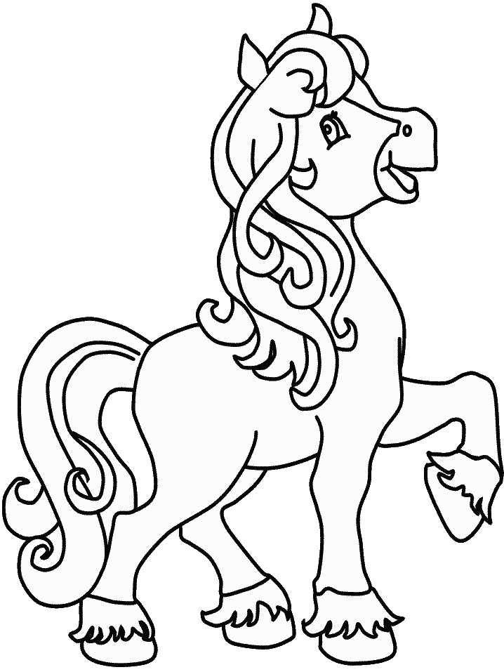[](http://www.google.com.tr/imgres?imgurl=http://bp1.blogger.com/_eUk-4litSCk/R8rZaJhlx4I/AAAAAAAAB-4/2JDELGY17wA/s400/deniz-yasemen.hayvanlar%2B(15).jpg&imgrefurl=http://www.forumalev.net/okul-oncesi-egitim/387089-winnie-the-pooh-boyama-sayfalari.html&usg=__M6ZIcfHjHzGUrZ-7fa7VrDwmOII=&h=400&w=299&sz=19&hl=tr&start=122&zoom=1&tbnid=m0JpIa75PeNgeM:&tbnh=126&tbnw=101&ei=NmQ4TZGCFoaN4AblvbzACg&prev=/images%3Fq%3Dhayvan%2Bresmi%2Bboyama%26hl%3Dtr%26biw%3D1276%26bih%3D545%26gbv%3D2%26tbs%3Disch:1&itbs=1&iact=rc&dur=437&oei=ImE4TcnpHomo8QOC5cCrCA&esq=5&page=6&ndsp=24&ved=1t:429,r:4,s:122&tx=86&ty=122)[](http://www.google.com.tr/imgres?imgurl=http://bp0.blogger.com/_eUk-4litSCk/R8raR5hlx-I/AAAAAAAAB_o/aU6laR1pTjI/s400/deniz-yasemen.hayvanlar%2B(9).jpg&imgrefurl=http://www.forumalev.net/okul-oncesi-egitim/387080-yuruyen-tirtil-boyama-sayfalari.html&usg=__HjXRVm47MtgnkPOzUD-xP_tvatc=&h=311&w=400&sz=18&hl=tr&start=364&zoom=1&tbnid=3qYX0K1SY7kGnM:&tbnh=112&tbnw=144&ei=6GU4TenaLJKq8AOo54mcCA&prev=/images%3Fq%3Dhayvan%2Bresmi%2Bboyama%26hl%3Dtr%26biw%3D1276%26bih%3D545%26gbv%3D2%26tbs%3Disch:1&itbs=1&iact=rc&dur=16&oei=W2U4TdKXFMeq8QP2lomwCA&esq=undefined&page=17&ndsp=21&ved=1t:429,r:7,s:364&tx=102&ty=43)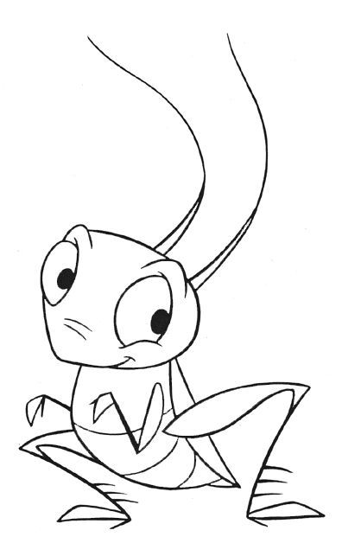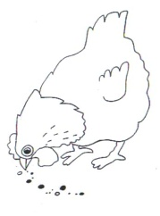

1 2 1 2

1 2 3 1 2 3

1 2 3 1 2

1 2 3